CS550 Project #3  
Xiaoru Chen  
Email: chenxia2@oregonstate.edu

A Screen shot from my program:

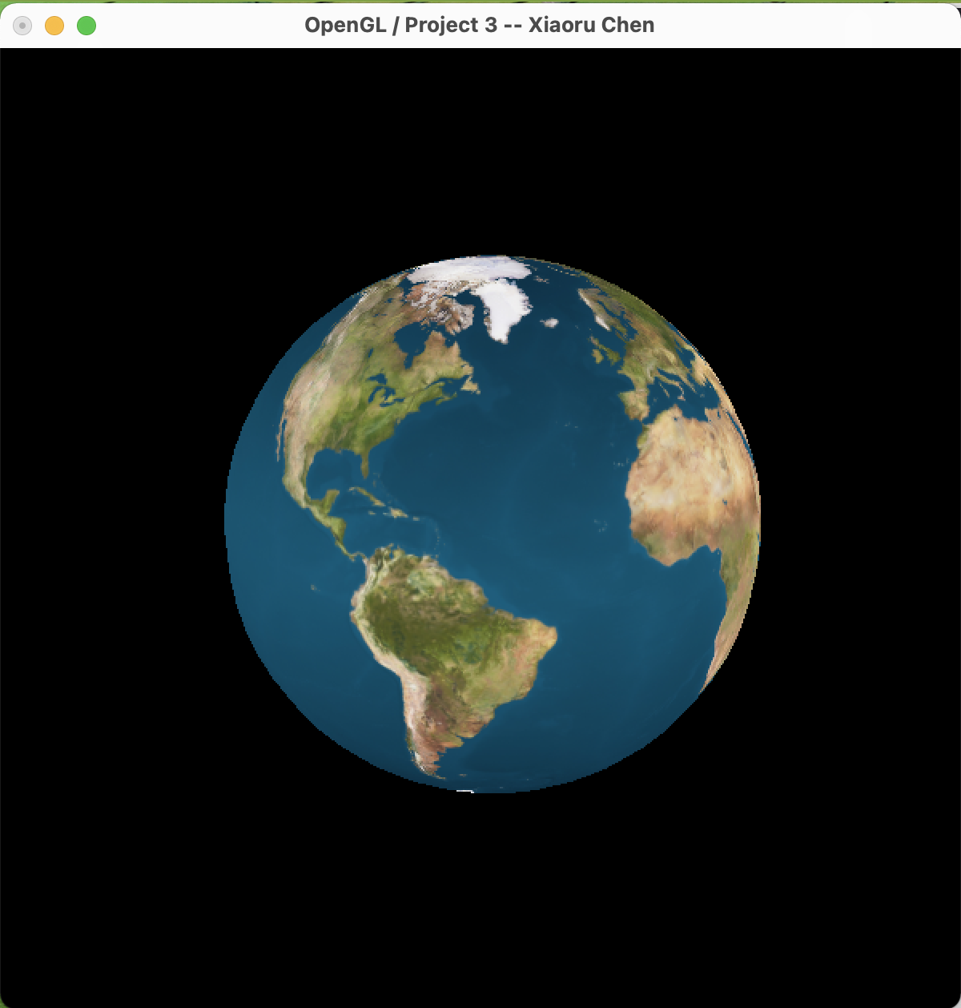

The link to the Kaltura video:

<https://media.oregonstate.edu/media/t/1_m7o5u8qm>